1. Introduction

In this project, we are going to develop an autonomous car using the TI-RSLK and the mmwave sensor (IWR1443BOOST). The autonomous car will be capable of different functions such as providing geographical information (such as range, velocity and angle) and proximity & position sensing.

## Backgound/Motivation

The TI Robotics Systems Learning Kit was created by TI as a low-cost robotics kit to provide students with a profound understanding of how electronic devices work. It was developed in conjunction with Dr Jon Valvano, professor, electrical and computer engineering at The University of Texas at Austin. There are two different RSLK kits; the basic kit which teaches the foundations of an electric system and the advanced kit which Contains all components found in basic kit, adding wireless communication to enable robot to solves its way through a maze by detecting lines and obstacles.

The mmwave sensor is an extremely valuable sensing technology for detection of objects and providing the range, velocity and angle of these objects. It is a contactless-technology which operates in the spectrum between 30GHz and 300GHz. Due to the technology’s use of small wavelengths it can provide sub-mm range accuracy and is able to penetrate certain materials such as plastic, drywall, clothing, and is impervious to environmental conditions such as rain, fog, dust and snow. The mmwave sensor has a clear advantage over other sensing technologies such as ultrasonic sensors and LIDAR. It has a long detection range, narrow and wide detection angle, good range resolution, and has good night operation performance.

## Objective

The objective is the design of an autonomous car which can provide geographical information such as the range, velocity, angle and 3D imaging of objects in an unknown area.

## Design Requirements

1. The device will be able to produce a data using a point cloud system
2. The device will be able to provide a 3D mapping of objects
3. The radar configuration will help calculate the ground speed independent of wheel rotation
4. The device would be able to work in different weather conditions. such as rain, snow e.t.c
5. The device will be able to perform mapping and navigation using mmWave sensors
6. Project Description

## System Description

An autonomous car is controlled by a Ti microcontroller MSP432 power by a 12-volt battery with a voltage regulator controlling the voltage input to the microcontrollers. The battery powers the Dc motor and sends the DC signal to a PWM input on the microcontroller. A IWR 1443 Boost mmwave Rader is connected to the microcontroller to server as a senor to the car. Also, a raspberry pi is connected to the output signal of the microcontroller to control, access and save the data acquire from the sensors.

## System Diagram

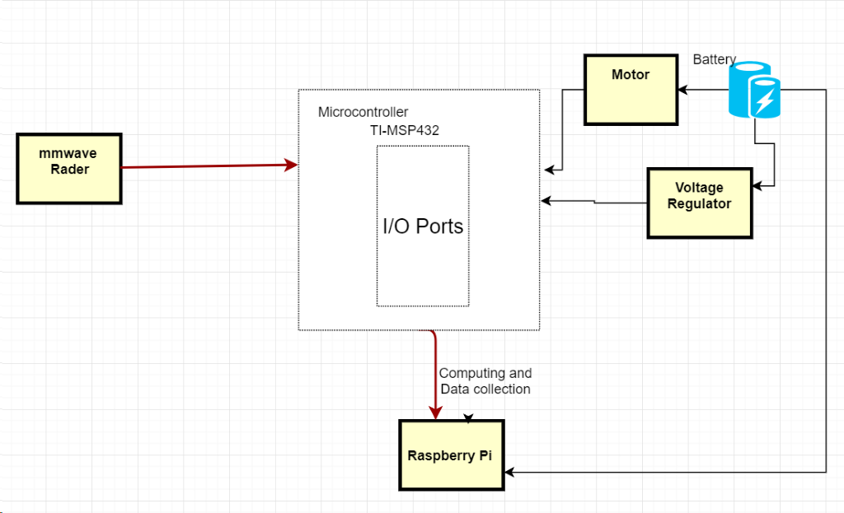

1. System Diagram.
2. Implementation Plan

## Tasks

*Task 1.* RLSK Setup

Subtask 1. Assembly of TI RSLK Kit

Subtask 2. Creating a Code

*Task 2.* Implementation of mmwave sensor (IWR1443Boost)

Subtask 1. Connecting the mmwave sensor to RSLK Kit

Subtask 2. Writing the Code for mmwave sensor

*Task 3*. Implementation of object detection and avoidance

*Task 4.* Implementation of point cloud information

*Task 5.* General calculation analysis

*Task 6.* Using Raspberry Pi for data analysis

*Task 7.* System testing and refinement

## Team Organization

### 3.2.1. Responsibility of Aduralere Sulaiman

Task 1, Subtask 1.2, 2.2, 4, 5, 7

***3.2.2.***  ***Responsibility of Favour Dada***

Task 1, Subtask 1.1, 2.1, 4, 5, 7

### 3.2.3. Responsibility of Jesudara Omidokun

Task 1, Subtask 1.1, 1.2, 3, 6, 7

.…

## Timeline/Milestones/Delivery Plan

1. Project Timeline and Delivery Plan

|  |  |  |  |
| --- | --- | --- | --- |
| **Time** | **Task** | **Comments** | **Responsible Personnel** |
| Week 1-5 |  | N/A |  |
| Week 5-8 | Finish Subtask 1.1  Start 1.2 | Assembly of the TI RSLK Kit  Working on the code | Aduralere Sulaiman  Jesudara Omidokun |
| Week 9-12 | Task 2: 2.1 and 2.2 | Connecting the mmWave to the RSLK  Writing the code for mmWave senor | Aduralere Sulaiman  Favour Dada |
| Week 13 | Task 3 | Implementation of Object Avoidance and detection | Jesudara Omidokun |
| Week 14-16 | Task 4 | Implementation of point cloud information | Favour Dada  Jesudara Omidokun |
| Week 16-19 | Task 5, 6 | General Calculation analysis  Using Raspberry Pi for data analysis | Favour Dada  Aduralere Sulaiman |
| Week 19-22 | Finish task 7 | System finalization and delivery. Finish all documentations and ready for presentation. | Aduralere Sulaiman  Jesudara Omidokun  Favour Dada |